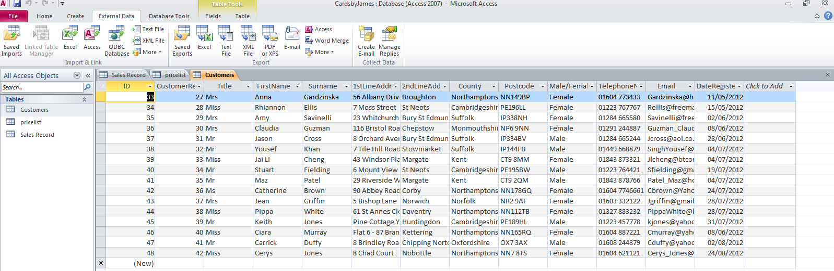Import all 3 tables customers, pricelist and sales record

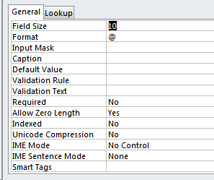Change the field size to a more suitable size:

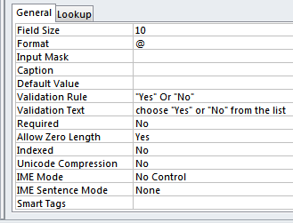Create a Validation Rule:

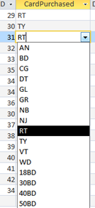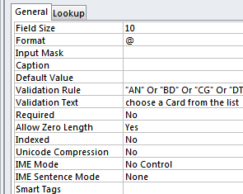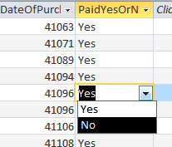Create a drop down list for the “PaidYesOrNo” field. Drop down list and validation rule for “CardPurchased” field.

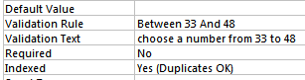“CustomerRefID” validation rule